Experiment 6
AIM: Create Product Catalog Application using ASP.NET MVC Architecture
Source: App_Start/RouteConfig.cs
Code:
using System;
using System.Collections.Generic;
using System.Linq;
using System.Web;
using System.Web.Mvc;
using System.Web.Routing;

namespace Practical_6
{
public class RouteConfig
{
public static void RegisterRoutes(RouteCollection routes)
{
routes.IgnoreRoute("{resource}.axd/{*pathInfo}");

routes.MapRoute(
name: "Default",
url: "{controller}/{action}/{id}",
defaults: new { controller = "ProductDetails", action = "Index", id = UrlParameter.Optional }
);
}
}
}

Source: Controllers/ProductDetailsController.cs

Code:

using Practical_6.Models;
using System;
using System.Collections.Generic;
using System.Linq;
using System.Web;
using System.Web.Mvc;

namespace Practical_6.Controllers
{
public class ProductDetailsController : Controller
{
// GET: ProductDetails
public ActionResult Index()
{
List<ProductDetails> P = GetData();

return View("Product", P);
}

public ActionResult Details(int id)
{
List<ProductDetails> pall = GetData();
ProductDetails p = new ProductDetails();
p = pall.FirstOrDefault(x => x.id == id);
return View("Details", p);
}

public List<ProductDetails> GetData()
{

List<ProductDetails> P = new List<ProductDetails>();

ProductDetails p1 = new ProductDetails();
p1.id = 1;
p1.imageUrl = "https://encrypted-tbn1.gstatic.com/shopping?q=tbn:ANd9GcSIxThfb1NeN5a1nd9aS9akzWXKflkpcAmVpJg5DmQxOHNvgGV_WwFMWebnn8W4JMp_17RusDurmmMNKDNG9HUhLZYj-CqeBkRAk-VAcChvsEuuFdVf-pTDjJ0";
p1.name = "Macbook";
p1.category = "Laptop";
p1.description = "Have a Premium Experience with Mac";
p1.price = 125000;

ProductDetails p2 = new ProductDetails();
p2.id = 2;
p2.imageUrl = "https://encrypted-tbn1.gstatic.com/shopping?q=tbn:ANd9GcQnEyJKAMpPsGtu7nAwExiwIfGw3M7nSK__UMia5r9zk3FQYvPZd3WbIHao80rK4O44Re4v232dzh43YxqGUqPAGMSFejBoF6vJCNiWpTeMkXVgorBIxMVV_iI";
p2.name = "Iphone";
p2.category = "Mobile";
p2.description = "Flagship Smartphome";
p2.price = 100000;

ProductDetails p3 = new ProductDetails();
p3.id = 3;
p3.imageUrl = "https://media-ik.croma.com/Croma%20Assets/Computers%20Peripherals/Laptop/Images/323258_0_2IVmGYybG.png?updatedAt=1783326925974&tr=w-640";
p3.name = "Omen";
p3.category = "Laptop";
p3.description = "Seamless Gaming Experience with omen";
p3.price = 150000;

P.Add(p1);
P.Add(p2);
P.Add(p3);

return P;
}
}
}

Source: Models/ProductDetails.cs

Code:

using System;
using System.Collections.Generic;
using System.Linq;
using System.Web;

namespace Practical_6.Models
{
public class ProductDetails
{
public int id { get; set; }
public string imageUrl { get; set; }

public string name { get; set; }

public string category { get; set; }

public string description { get; set; }

public int price { get; set; }

}
}

Source: Views/ProductDetails/Details.cshtml

Code:

@model Practical_6.Models.ProductDetails
@{
Layout = null;
}

<!DOCTYPE html>

<html>
<head>
<meta name="viewport" content="width=device-width" />
<title>Details</title>
</head>
<body>
<div>
<img src="@Model.imageUrl" width="150" height="150" />
<br />

<p>Product Category: @Model.category</p>
<br />

<p>Product Name: @Model.name</p>
<br />

<p>Product Description: @Model.description</p>
<br />

<p>Product Price: @Model.price</p>
<hr />

@Html.ActionLink("Back", "Index", "ProductDetails")
</div>
</body>
</html>

Source: Views/ProductDetails/Product.cshtml

Code:

@model List<Practical_6.Models.ProductDetails>
@{
Layout = null;
}

<!DOCTYPE html>

<html>
<head>
<meta name="viewport" content="width=device-width" />
<title>Product</title>
</head>
<body>
<div>
<h2>Product Details</h2>

@foreach (var i in Model)
{
<img src="@i.imageUrl" width="150" height="150" />

<h3>Product Name: @i.name</h3>

<h4>Product Category: @i.category</h4>

<h4>Product Price: @i.price</h4>

@Html.ActionLink("Click for more details", "Details", "ProductDetails", new { id = i.id }, null)

<hr />

}
</div>
</body>
</html>

Output:
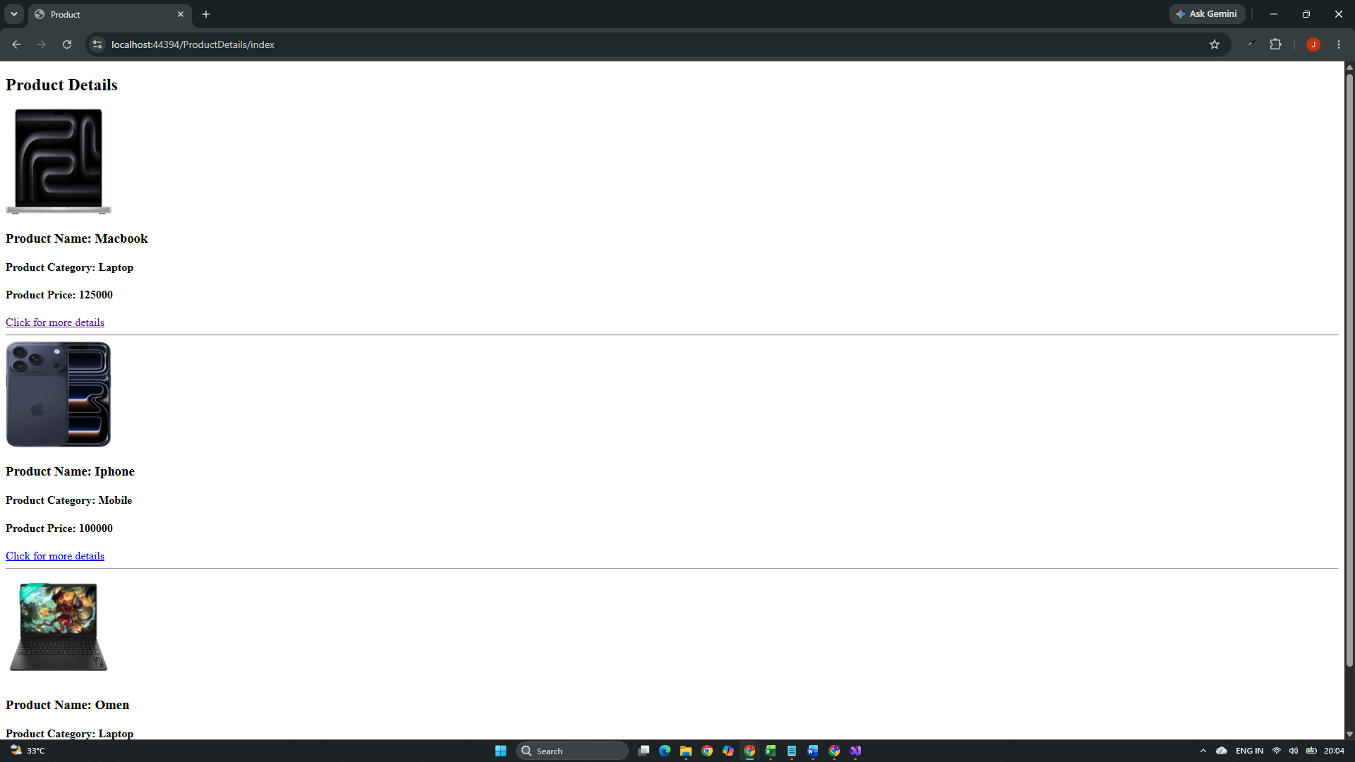

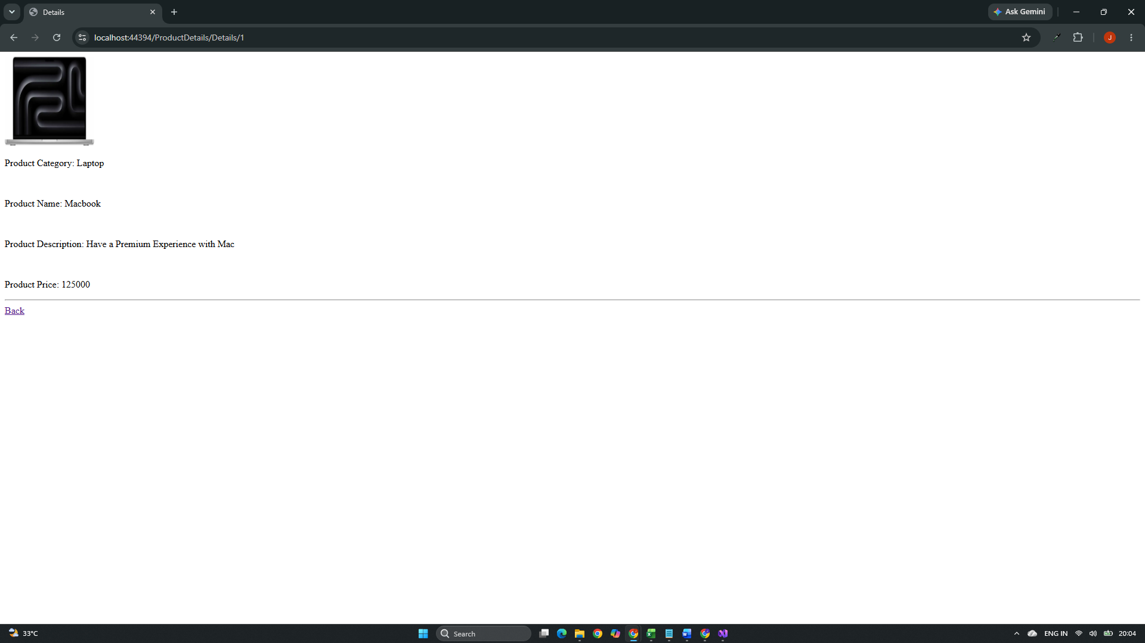

Github Url: https://github.com/jd-thakrar/Uni-DotNet-Work/tree/master/Practical-6

